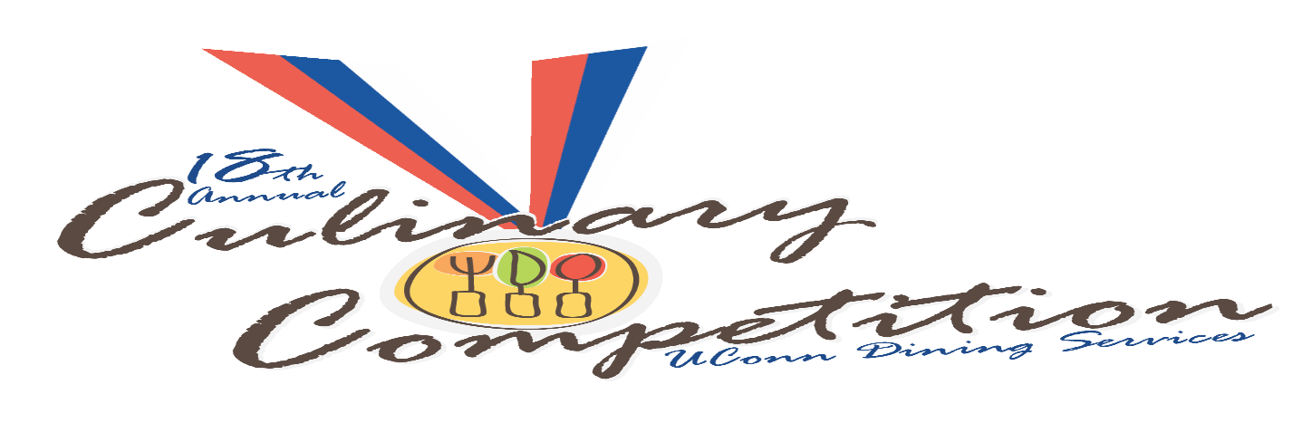

Recipe Contest

Appetizers

First Place

Prosciutto, Mozzarella & Spinach Arancini with Marinara Sauce
Charlie String

Second Place

Chili with Chipotle and Chocolate
Donna Johnston

Third Place

Hawaiian Spam Spring Rolls
Mathew Gorr

Entrée’s

First Place

Kyle Davis
Seared Pollock with Cilantro Lime Pesto and Hot & Sour Broth

Second Place

“Chiles en Nogada”
Bryan Martinez

Third Place

Jamaican Oxtail Stew
Lucy Simms

Desserts

First Place

The Black Pearl
Curtis Bangs

Second Place

Coffee Cheesecake
Alexis Saucier

Third Place

Amanada Fitzgerald (Emanuele)
Trio of Cupcakes

Boiling Point Competition

First Place

Team 6- Putnam
Mathew Nichols, Bill Mckay, Hannah Lee

Apple/Lychee Compote w/Ginger Marshmallow Topping
Crab Gnocchi Alfredo
Duck Fat Braised Pork Cutlet w/Lychee Cider Sauce

Second Place

Team 9-McMahon
Keith Ouellette, Jacob Kochol, Andrew McMullen

Snowball Ambrosia Salad
Lump Gefilte Fish Over Greens w/Lychee Vinaigrette
Braised Red Wine Pork Ragu w/Shave Pear Salad & Potato Crostini

Third Place

Team 1-Mcmahon
Gary Ellis, Scott Chapman, Susan Chang

Potato & Onion Chowder w/Snowball Crusted Crab
Lychee & Pork Shank Egg Sushi
Green Tea Rice Snowball Stuffed w/Lychee

Honorable Mention
For Best Tapas

Team 7-Gelfenbien
Lucy Simms, Amy Gronus, Donna Johnston

Pork & Kale Quesadilla w/Lychee & Chili Salsa

