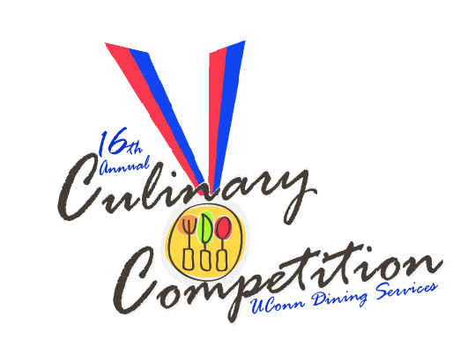
Recipe Contest

Appetizers

1st Place
“Hair of the dog, gruff nod to breakfast at noon”
Kristina Breuninger

2nd Place
Lamb and Red Lentil Soup
Alexis Saucier

3rd Place
Captain of the Sea
Donna Johnston

Entrée’s

1st Place
Shrimp with Squid and Carrot Pastas with Brown Butter Sage Sauce
Alexis Saucier

2nd place
Pesto Encrusted Sword Fish Filet with Tomato Beurre Blanc
Mathew Nichols

3rd Place
Coq au Vin
Charlie String

Desserts

1st Place
Death by Poe-Chocolate
Hector Vega

2nd Place
“Gluten Free Honey Lavender Croquembouche”
Kristina Breuninger

3rd Place

Gluten Free Almond Cake with Salted Caramel Earl Grey Ice Cream
Alexis Saucier
Boiling Point Competition

Mystery Basket: Alligator, Sunchokes, Anchovies, Buddha’s Hand, Apple Pie.
Additional Twists: Chocolate Syrup, Coriander Pesto, Mango Pesto

1st Place

Team 6 Union Street Market
Richard Granja, Omayra Quiles, Peter Diani
Potato Sunchoke Cake w/white balsamic Anchovie
Bruchia
Gator & French Toast w/Mango Chutney Maple Drizzle
Apple Chutney wontons w/Maple Whipped Cream

2nd Place

Team 4 Central Production Kitchen
Sean FitzGerald, Melissa Grindal, Heidi Howlett

Budda Canapee w/Roasted Harvest Pie
Plated w/ a Cognac Gastrique
Gator Tika Kabob w/a cucumber fresh salad
Summer time sunchoke and anchovies, fresh citrus zest

3rd Place

Team 11Gelfenbien
Lucinda Simms, Donna Johnston, Scott Chapman

Alligator Spring Roll w/Apricot Gaina Glaze
Apple Pie & Anchovies Wonton
Budda’s Citrus Parfait w/Chocolate & Apple Pie Crumble

